Functional connectivity of the orbitofrontal cortex, anterior cingulate cortex,
and inferior frontal gyrus in humans
Cortex 123: 185-199 (2020)

Supplementary Material

Jingnan Du^{a,b,#}, Edmund T. Rolls^{a,c,d,#}, Wei Cheng^{a, b,*}, Yu Li^{e,#} , Weikang Gongª, Jiang Qiu^{e}, and Jianfeng Feng^{a, 2,3 **}

a. Institute of Science and Technology for Brain-inspired Intelligence, Fudan University, Shanghai, 200433, PR China
b. Key Laboratory of Computational Neuroscience, Institute of Science and Technology for Brain-inspired Intelligence, Fudan University, Ministry of Education, China
c. Department of Computer Science, University of Warwick, Coventry CV4 7AL, UK
d. Oxford Centre for Computational Neuroscience, Oxford, UK
e. Key Laboratory of Cognition and Personality (SWU), Ministry of Education, Chongqing, China.

# Co-first author.

Table S1. The anatomical regions defined in each hemisphere and their label in the automated anatomical labelling atlas AAL3 (Rolls, Huang, Lin, Feng, & Joliot, 2020). The regions that have been redefined in AAL3 compared to AAL2 (Rolls, Joliot, & Tzourio-Mazoyer, 2015) are shown in italics. Column 4 provides a set of possible abbreviations for the anatomical descriptions.
NO. | ANATOMICAL DESCRIPTION | LABEL  Aal3.nii.gz | POSSIBLE  ABBREVIATION
1,2 | Precentral gyrus | Precentral | PreCG
3, 4 | Superior frontal gyrus, dorsolateral | Frontal_Sup | SFG
5, 6 | Middle frontal gyrus | Frontal_Mid | MFG
7, 8 | Inferior frontal gyrus, opercular part | Frontal_Inf_Oper | IFGoperc
9, 10 | Inferior frontal gyrus, triangular part | Frontal_Inf_Tri | IFGtriang
11, 12 | Inferior frontal gyrus, pars orbitalis | Frontal_Inf_Orb | IFGorb
13, 14 | Rolandic operculum | Rolandic_Oper | ROL
15, 16 | Supplementary motor area | Supp_Motor_Area | SMA
17, 18 | Olfactory cortex | Olfactory | OLF
19, 20 | Superior frontal gyrus, medial | Frontal_Sup_Med | SFGmedial
21, 22 | Superior frontal gyrus, medial orbital | Frontal_Med_Orb | PFCventmed or VMPFC
23, 24 | Gyrus rectus | Rectus | REC
25, 26 | Medial orbital gyrus | OFCmed | OFCmed
27, 28 | Anterior orbital gyrus | OFCant | OFCant
29, 30 | Posterior orbital gyrus | OFCpost | OFCpost
31, 32 | Lateral orbital gyrus | OFClat | OFClat
33, 34 | Insula | Insula | INS
35, 36 | Anterior cingulate & paracingulate gyri | Cingulate_Ant | ACC
37, 38 | Middle cingulate & paracingulate gyri | Cingulate_Mid | MCC
39, 40 | Posterior cingulate gyrus | Cingulate_Post | PCC
41, 42 | Hippocampus | Hippocampus | HIP
43, 44 | Parahippocampal gyrus | ParaHippocampal | PHG
45, 46 | Amygdala | Amygdala | AMYG
47, 48 | Calcarine fissure and surrounding cortex | Calcarine | CAL
49, 50 | Cuneus | Cuneus | CUN
51, 52 | Lingual gyrus | Lingual | LING
53, 54 | Superior occipital gyrus | Occipital_Sup | SOG
55, 56 | Middle occipital gyrus | Occipital_Mid | MOG
57, 58 | Inferior occipital gyrus | Occipital_Inf | IOG
59, 60 | Fusiform gyrus | Fusiform | FFG
61, 62 | Postcentral gyrus | Postcentral | PoCG
63, 64 | Superior parietal gyrus | Parietal_Sup | SPG
65, 66 | Inferior parietal gyrus, excluding supramarginal and angular gyri | Parietal_Inf | IPG
67, 68 | SupraMarginal gyrus | SupraMarginal | SMG
69, 70 | Angular gyrus | Angular | ANG
71, 72 | Precuneus | Precuneus | PCUN
73, 74 | Paracentral lobule | Paracentral_Lobule | PCL
75, 76 | Caudate nucleus | Caudate | CAU
77, 78 | Lenticular nucleus, Putamen | Putamen | PUT
79, 80 | Lenticular nucleus, Pallidum | Pallidum | PAL
81, 82 | Thalamus | Thalamus | THA
83, 84 | Heschl’s gyrus | Heschl | HES
85, 86 | Superior temporal gyrus | Temporal_Sup | STG
87, 88 | Temporal pole: superior temporal gyrus | Temporal_Pole_Sup | TPOsup
89, 90 | Middle temporal gyrus | Temporal_Mid | MTG
91, 92 | Temporal pole: middle temporal gyrus | Temporal_Pole_Mid | TPOmid
93, 94 | Inferior temporal gyrus | Temporal_Inf | ITG
95, 96 | Crus I of cerebellar hemisphere | Cerebellum_Crus1 | CERCRU1
97, 98 | Crus II of cerebellar hemisphere | Cerebellum_Crus2 | CERCRU2
99, 100 | Lobule III of cerebellar hemisphere | Cerebellum_3 | CER3
101, 102 | Lobule IV, V of cerebellar hemisphere | Cerebellum_4_5 | CER4_5
103, 104 | Lobule VI of cerebellar hemisphere | Cerebellum_6 | CER6
105, 106 | Lobule VIIB of cerebellar hemisphere | Cerebellum_7b | CER7b
107, 108 | Lobule VIII of cerebellar hemisphere | Cerebellum_8 | CER8
109, 110 | Lobule IX of cerebellar hemisphere | Cerebellum_9 | CER9
111, 112 | Lobule X of cerebellar hemisphere | Cerebellum_10 | CER10
113 | Lobule I, II of vermis | Vermis_1_2 | VER1_2
114 | Lobule III of vermis | Vermis_3 | VER3
115 | Lobule IV, V of vermis | Vermis_4_5 | VER4_5
116 | Lobule VI of vermis | Vermis_6 | VER6
117 | Lobule VII of vermis | Vermis_7 | VER7
118 | Lobule VIII of vermis | Vermis_8 | VER8
119 | Lobule IX of vermis | Vermis_9 | VER9
120 | Lobule X of vermis | Vermis_10 | VER10

Table S2. The extra anatomical regions defined AAL3 (Rolls et al., 2020) in each hemisphere (compared to AAL2 (Rolls et al., 2015)) and their label. Column 4 provides a set of possible abbreviations for the anatomical descriptions. In AAL3, the label shown in column 3 is followed by the number shown in column 1. In most cases, the first number in a row is for the left hemisphere, and the second number is for the right hemisphere. This does not apply to the raphe, which is a midline structure.
NO. | ANATOMICAL DESCRIPTION | LABEL  aal3.nii.gz | POSSIBLE  ABBREVIATION
121, 122 | Thalamus, Anteroventral Nucleus | Thal_AV | tAV
123, 124 | Lateral posterior | Thal_LP | tLP
125, 126 | Ventral anterior | Thal_VA | tVA
127, 128 | Ventral lateral | Thal_VL | tVL
129, 130 | Ventral posterolateral | Thal_VPL | tVPL
131, 132 | Intralaminar | Thal_IL | tIL
133, 134 | Reuniens | Thal_Re | tRe
135, 136 | Mediodorsal medial magnocellular | Thal_MDm | tMDm
137, 138 | Mediodorsal lateral parvocellular | Thal_MDl | tMDl
139, 140 | Lateral geniculate | Thal_LGN | tLGN
141, 142 | Medial Geniculate | Thal_MGN | tMGN
143, 144 | Pulvinar anterior | Thal_PuA | tPuA
145, 146 | Pulvinar medial | Thal_PuM | tPuM
147, 148 | Pulvinar lateral | Thal_PuL | tPuL
149, 150 | Pulvinar inferior | Thal_PuI | tPuI
151, 152 | Anterior cingulate cortex, subgenual | ACC_sub | ACCsub
153, 154 | Anterior cingulate cortex, pregenual | ACC_pre | ACCpre
155, 156 | Anterior cingulate cortex, supracallosal | ACC_sup | ACCsup
157, 158 | Nucleus accumbens | N_Acc | Nacc
159, 160 | Ventral tegmental area | VTA | VTA
161, 162 | Substantia nigra, pars compacta | SN_pc | SNpc
163, 164 | Substantia nigra, pars reticulata | SN_pr | SNpr
165, 166 | Red nucleus | Red_N | RedN
167, 168 | Locus coeruleus | LC | LC
169 | Raphe nucleus, dorsal | Raphe_D | RapheD
170 | Raphe nucleus, median | Raphe_M | RapheM

Fig. S1. The 24 parcels shown on coronal slices. The Y value in MNI space is provided.
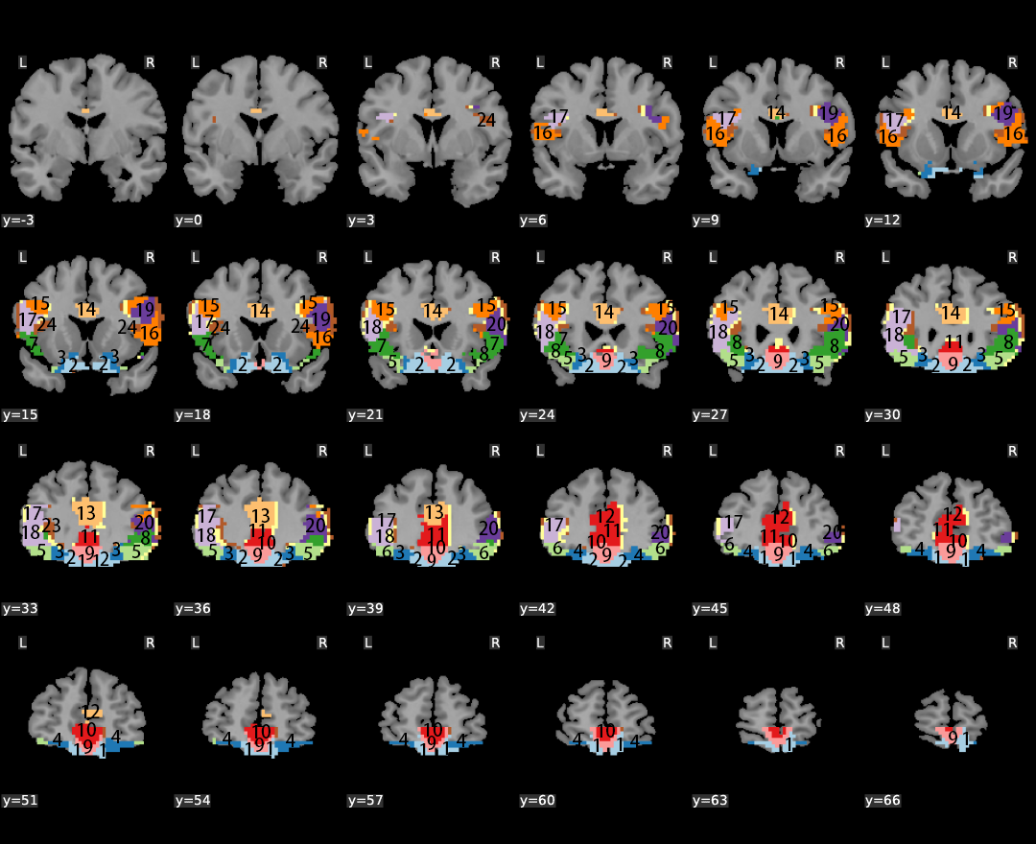

References

Rolls, E. T., Huang, C. C., Lin, C. P., Feng, J., & Joliot, M. (2020). Automated anatomical labelling atlas 3. Neuroimage, 206, 116189. doi: 10.1016/j.neuroimage.2019.116189
Rolls, E. T., Joliot, M., & Tzourio-Mazoyer, N. (2015). Implementation of a new parcellation of the orbitofrontal cortex in the automated anatomical labeling atlas. Neuroimage, 122, 1-5. doi: 10.1016/j.neuroimage.2015.07.075

